

**Project 1.3.9 Tools for Collaboration**

Teacher Notes: Setting up the Team

Introduction

|  |  |
| --- | --- |
| An important tool for collaboration is a version control system. Have you ever found it difficult to keep papers well organized? What happens when 20 people all work on the same document? | Github.com/about |

Materials

* Computer with Enthought Canopy distribution of *Python*® programming language
* GitHub individual account and membership in teacher’s organizational account

Procedure

Part I: Create an Organizational Account with Private Repos

1. The teacher should sign up for an individual account at <https://github.com>. The username can only contain alphanumeric characters and hypens. Students will see this name, but it is associated with the individual teacher, not the school.

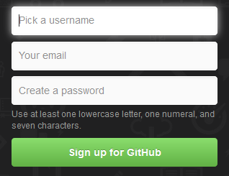

1. Obtain an organizational account as follows:
   1. Log in to your GitHub account at <https://github.com> using the credentials you just created.
   2. On GitHub’s website, select the context-setting menu.

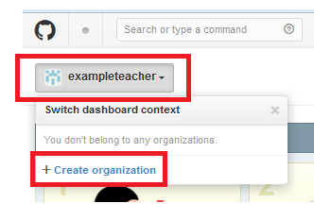

* 1. Create an organization for yourself at your school. Each teacher at a school should create their own organizational account. Name it CSP-YourSchoolNameHS-YourGitHubName. Provide your school email address.

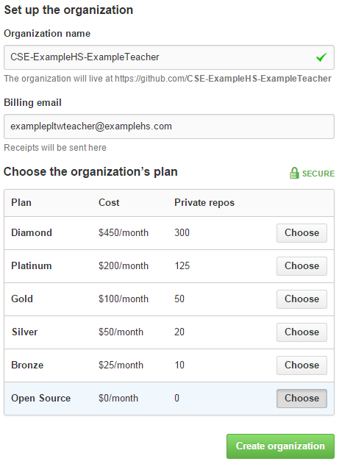

* 1. Finish creating the free GitHub organization that has zero private repositories.

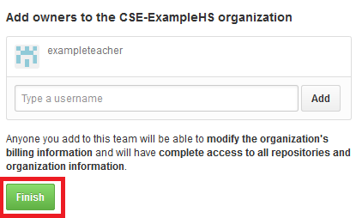

1. Verify the email address with which you registered.
   1. Select the wrench icon for Account settings. Select Emails from the menu at left. Select **Verify** for your school email address.

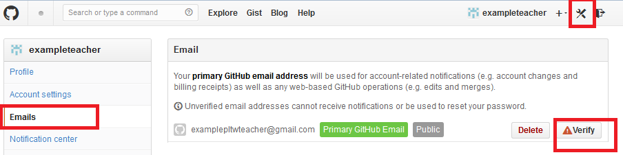

* 1. Open that email and the follow the link it contains. Note that you should only follow a link in an email when you are absolutely certain the email is from who it purports to be from.

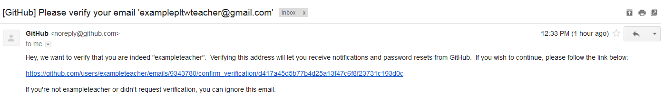

* 1. When the link to the GitHub website opens in your browser, **Confirm** the verification.

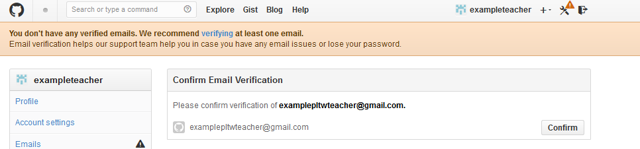

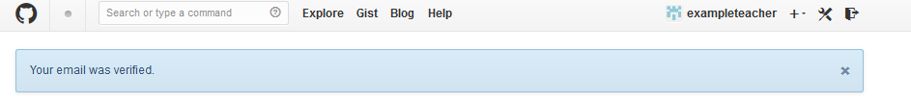

1. Request private repositories on behalf of your organization by navigating to <http://education.github.com>.
   1. Near the bottom of the page, request a discount.

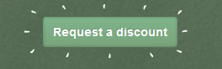

* 1. Describe yourself as a teacher and request a discount for your organization's account.

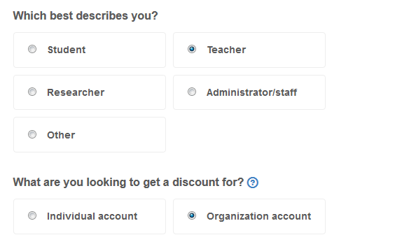

* 1. Identify and describe your organization and select Next.

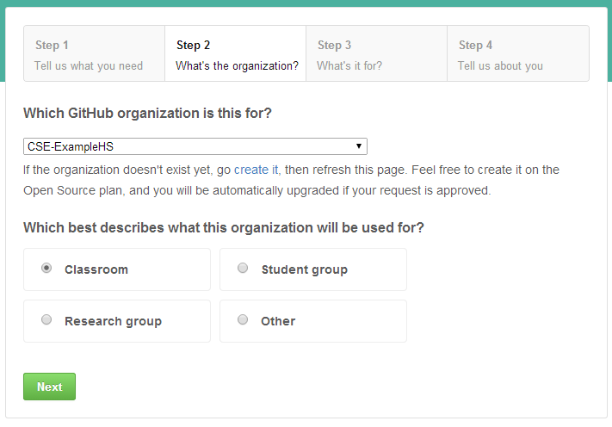

1. Provide a URL for your course or course catalog and request 125 or 70 private repositories. You will use one repository for each section of CSP for Project 1.3.9-10. Students can get their own private repositories for other projects and problems if they request them from GitHub, or they can use private repos from your organization.

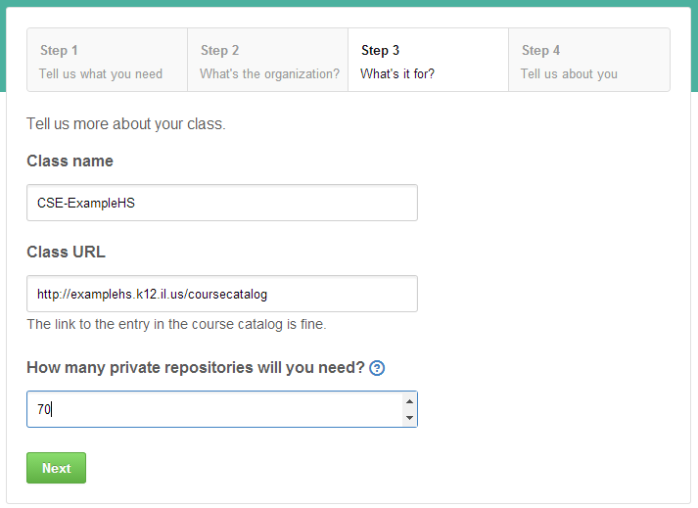

1. If GitHub's algorithm does not recognize your verified email as a school address, you may be asked to provide more information. Use your own text or the following text as description.

Students will collaborate in a round robin tournament in which each pair of students codes one strategy in Project 1.3.9-10 of Computer Science Princples (CSP) from Project Lead The Way.

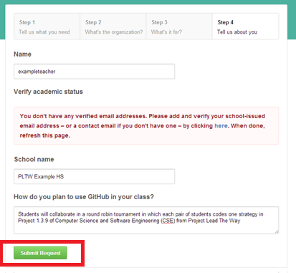

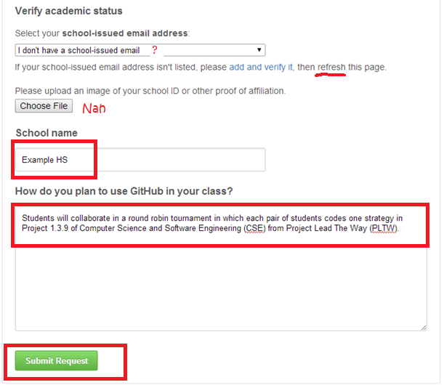

**Part II: Set up a Team**

1. Launch GitHub for Windows.

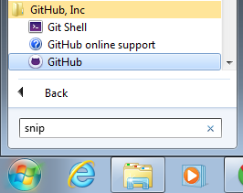

1. Enter your individual GitHub credentials and select **login**.

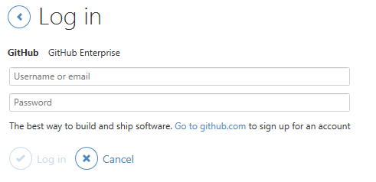

1. Create a new local repository by selecting **create** in the main console. Title the repository “iterative-prisoners-dilemma” or another name if you wish. You will want a repository for each section of CSP, so if you have more than one, distinguish between them when creating the repositories in this step. A folder will be created with this name. Select a local path for the repo's folder. The default directory is probably okay, but note where it is. Click **Create repository**.

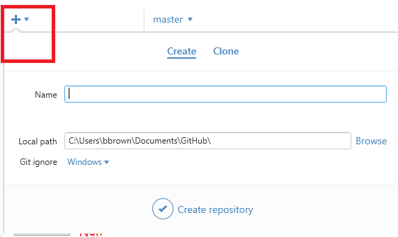

1. Add the needed files to the local repository as follows.
   1. Right-click on the name of the repository and select **Open in Explorer**.

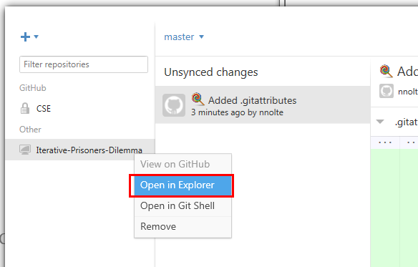

* 1. Using Windows® Explorer, copy the file prisoners_dilemma.py from the 1.3.9 sourceFiles.zip and paste it into the ‘iterative-prisoners-dilemma’ repo folder.
  2. Return to the GitHub for Windows main console. You should see the *Python* file listed among three files on the left side of the repository screen and a notice on the right side that uncommitted changes exist. Enter relevant notes about this commit, such as “original file” for the commit message and “Implements several strategies and the overall tournament functions” for the extended description of this particular commit. Select **Commit**.

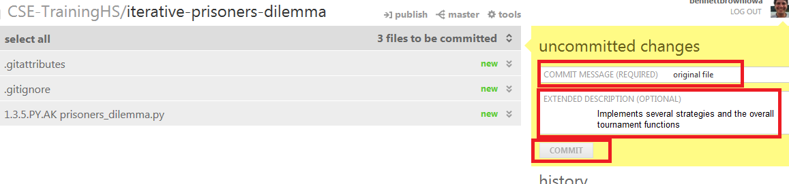

1. Do not change this copy of the code unless you are comfortable with GitHub. Changes made to the code within the GitHub directory will be reflected in the code that students use.

If you would like to make changes to the code just for your own experimentation, copy the code to another directory and make your changes in the copy outside of your GitHub directory.

If you make changes to the copy of the code within your GitHub directory after students have cloned it, beware any changes that affect the same lines of code that are being modified by students. These changes could create merge conflicts, just as if two student teams change the same code. If you encounter merge conflicts, you will need a Git shell to resolve the merge conflicts, a task beyond the scope of this course.

1. Publish the repository as follows.
   1. In the repository screen of GitHub for Windows, select **Publish Repository** to synchronize your local and cloud repositories.

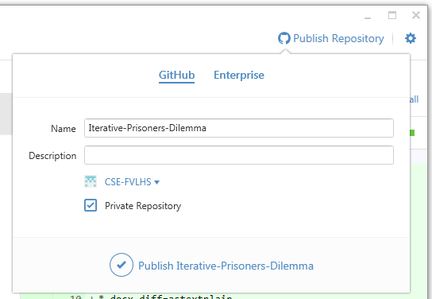

* 1. Type a description for the repository such as “Classroom collaboration to explore best algorithmic strategies in the IPD.”
  2. Select your organizational account, typically CSE-YourSchoolNameHS-YourGitHubName, as shown below. Only your organizational account has private repositories.
  3. Select **Private Repository**.
  4. Click **Publish <name of repository>**.

1. Create Teams and assign them the repository as follows.
   1. Open a web browser and login to github.com using your individual account credentials.
   2. Use the context-setting menu to change to your organizational context, named CSE-YourSchoolNameHS-YourGitHubName.

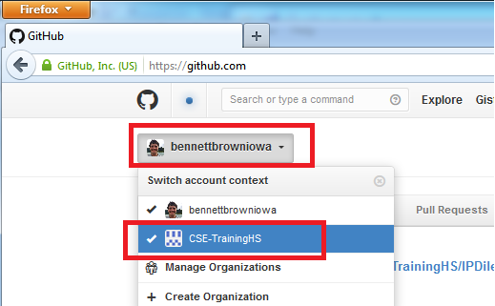

* 1. Select **View <Organization Name>**.

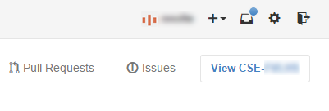

* 1. Select **Create new Team**.
  2. Enter “IPD Tournament” or a similar name for the team. Ensure **Read Access** is selected and click **Create Team**.
  3. Add student members to the team. Students will have had to create free GitHub accounts in order to be added to the team. Add at least one student from each two-person team. Use the **Add a person** search box to find the students after they have communicated to you their GitHub name.
  4. Add the repository to the team. Click on **Repositories** and use the **Add repositories** search box to find the repository you created.